**Weekly Report**

**On**

**Cloud Computing -Deploying a static website**

**Prepared**

**By**

**Rayalla Vandana**

(STU61fb5e0a8c6a71643863562)

Department of Computer Science Engineering

Sanskrithi Group of Institutions

Jawaharlal Nehru Technological University, Anantapur

November 2022

**Week 1**

**Agenda:**

The main agenda for deploying static portfolio website is, I am final year student at Sanskrithi School of Engineering affiliated to Jawaharlal technological university, Anantapur. I was started applying to many jobs. One of the most common thing I have noticed is that, the companies are asking for my portfolio and since I haven’t had, so I am going to build my portfolio website.

**Problem Statement:**

Creating a Portfolio Website which contains the details of a student like, Technical Skills, Certifications, Internships and Contact details.

**End Users:**

The end users for my portfolio website is for the recruiters of the jobs that I looking for.

**Week 2**

**Proposed Solution:**

Portfolios are great way to demonstrate the competencies you would list on a resume. During a Job search, the portfolio showcases your work to potential employers. It presents evidence of your relevant skills and abilities.

 It's like an evergreen platform for your projects, case studies, and information about you. In addition, it's one of the best ways to express your personality, experience, and capabilities.

**Technologies used:**

* HTML
* CSS

**Week 3**

**Modelling:**

A portfolio website provides professional information about an individual or a company and presents a showcase of the work. A portfolio will give more people access to your work and a better idea of your abilities.

A portfolio is a Unique way to showcase your work and let others know about yourself.

For developing this website, I used HTML and CSS.

My Portfolio website contains 5 sections those are:

* About
* Skills
* Certifications
* Internships
* Contact

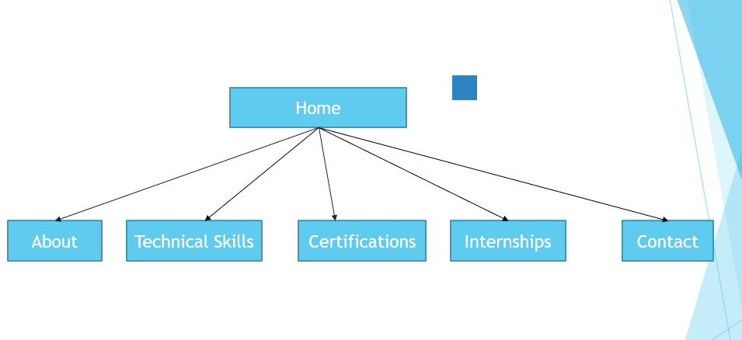

**Week-4**

**Link for the Website (Hosted on GitHub):**

https://github.com/rayallavandana/rayallavandana.github.io